

* After Successful login, user is redirected to the page as shown in page 3 of this document.

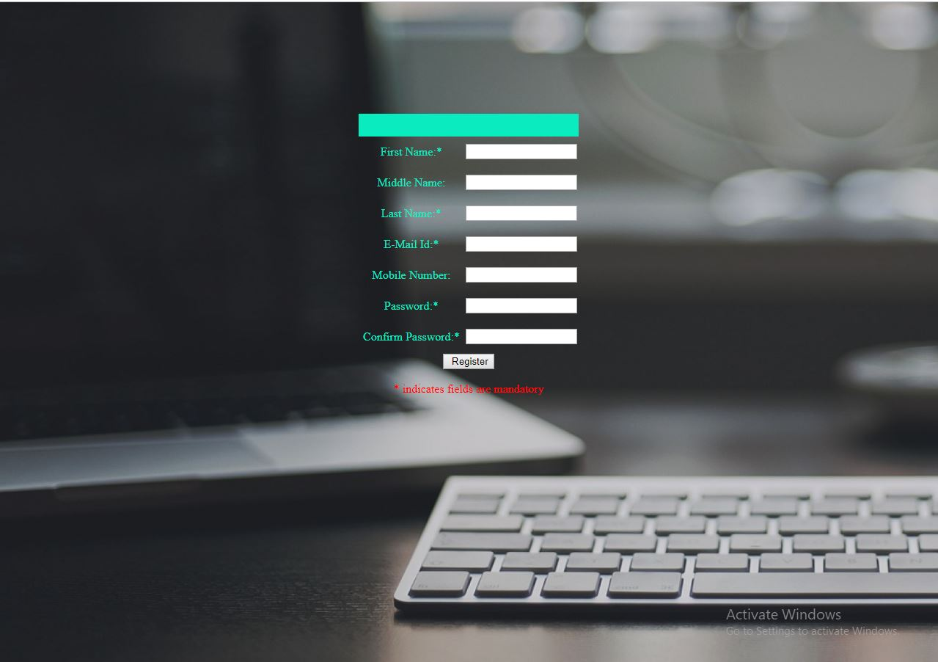

* Users have to register with details mentioned where middle name and mobile no. are optional.
* After successful registration user redirected to home page as shown in page 1 of this document.

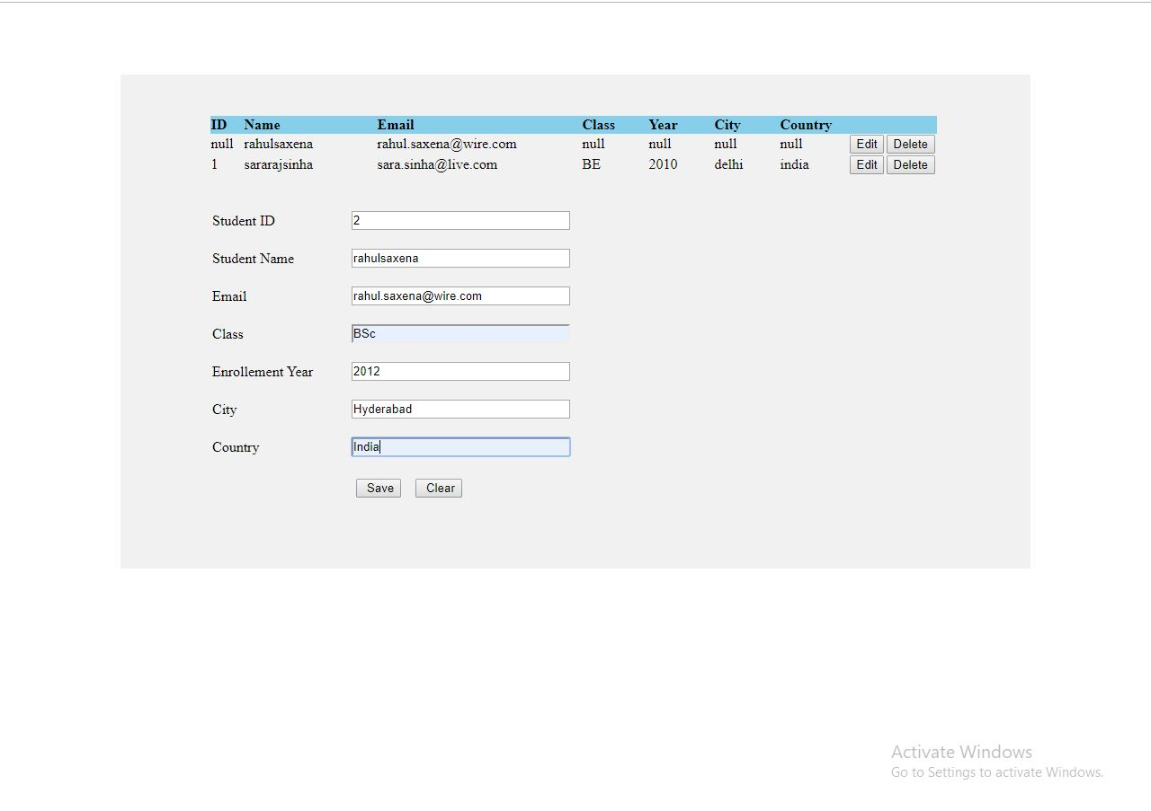

* This is manage users dashboard where CURD operations are performed.
* Class, year, city, country are showing null because, while registering we are not giving such details.
* By using edit button we can edit those values and save them, this can be seen in page 4 of this document.

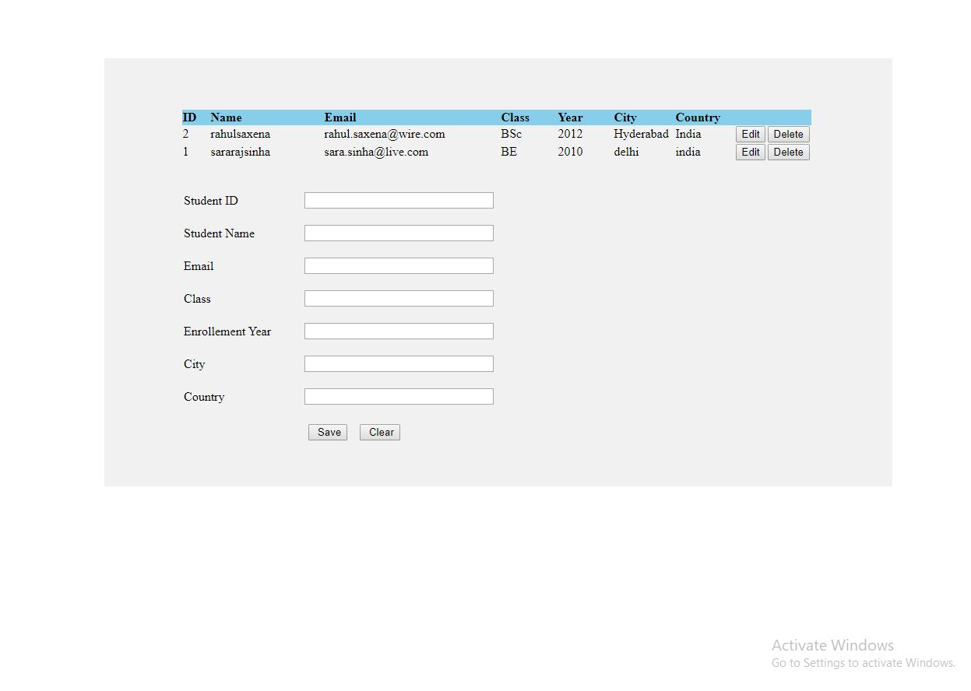

* Delete button is used to delete entire user details, this can be seen in page 5 of this document.

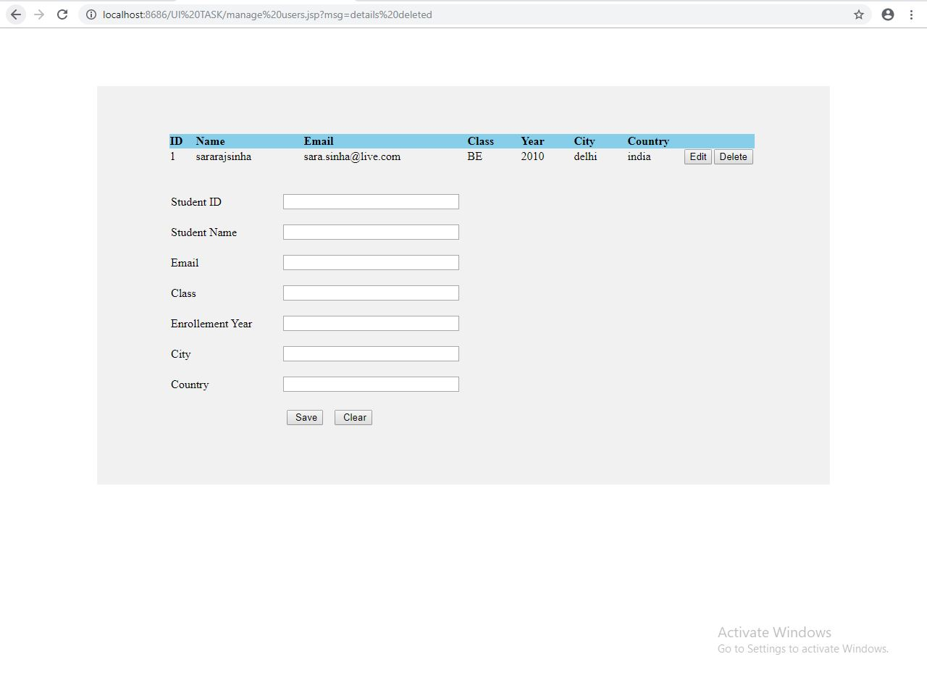

* **Front End** : HTML,JS
* **Back End** :JSP
* **Database**: Oracle 11g
* **Querying Language**: SQL
* **Apache Tomcat Server**